

T700**(E)**(A4)T

**NATIONAL CERTIFICATE**

# FITTING AND MACHINING THEORY N2

(11022032)

**4 April 2018 (X-Paper)**

**09:00–12:00**

**This question paper consists of 9 pages and 1 formula sheet.**

## DEPARTMENT OF HIGHER EDUCATION AND TRAINING

**REPUBLIC OF SOUTH AFRICA**

NATIONAL CERTIFICATE

FITTING AND MACHINING THEORY N2

TIME: 3 HOURS

MARKS: 100

**NOTE:** If you answer more than the required number of questions, only the required number will be marked. ALL work you do not want to be marked must be crossed out clearly.

### INSTRUCTIONS AND INFORMATION

1. Answer ALL the questions in SECTION A, except for QUESTION 1 where you must answer either QUESTION 1.1 OR QUESTION 1.2.

1. Answer only TWO questions in SECTION B.

1. Read ALL the questions carefully.

1. Number the answers according to the numbering system used in this question paper.

1. Write neatly and legibly.

**SECTION A**

### QUESTION 1: OCCUPATIONAL SAFETY

**NOTE:** Answer ONLY QUESTION 1.1 OR QUESTION 1.2.

1.1 Answer the following questions with regard to machine guarding:

1.1.1 State any TWO features of an effective machine guard. (2)

1.1.2 Name THREE types of safety guards used on machinery. (3)

**[5]**

### OR

1.2 Answer the following questions with regard to the mining industry:

1.2.1 Explain what is meant by *place of accidents to be left undisturbed*. (2)

1.2.2 State the THREE exceptions when it is not possible to keep to the

principle of a *place of accident to be left* *undisturbed*. (3)

**[5]**

### QUESTION 2: COUPLINGS

2.1 List the THREE main groups into which couplings are classified. (3)

2.2 Name THREE components of a typical coupling. (3)

**[6]**

### QUESTION 3: LIMITS AND FITS

FIGURE 1 shows diagrams of the THREE types of Engineering fits.

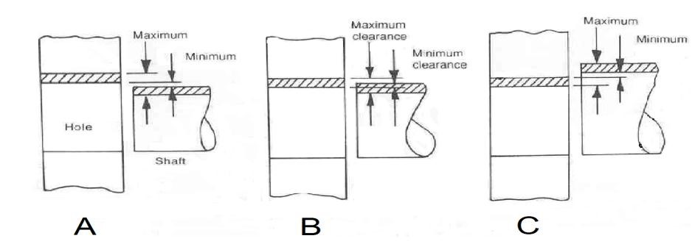

**FIGURE 1**

3.1 Name the types of fits labelled A, B and C. Write only the answer next to the

letter (A–C) in the ANSWER BOOK. (3)

3.2 State THREE factors which influence a clearance fit. (3)

3.3 Name the type of fit under which a *shrink fit* falls. (1)

**[7]**

**QUESTION 4: BEARINGS**

List FIVE causes of overheating in plain bearings. **[5]**

### QUESTION 5 : LUBRICANTS AND VALVES

5.1 Lubricants are classified as solid, semi-solid and liquid types.

State the classification of the lubricant used in each of the following lubricators:

5.1.1 Splash feed lubricator

5.1.2 Stauffer cup lubricator

5.1.3 Oil gun

(3 × 1) (3)

5.2 Name THREE types of shut-off valves. (3)

**[6]**

### QUESTION 6: PACKING, STUFFING BOXES, JOINTS AND WATER-PIPE SYSTEMS

6.1 FIGURE 2 below shows a diagram of a stuffing box.

Name the parts labelled A–E. Write only the answer next to the letter (A–E) in the ANSWER BOOK.

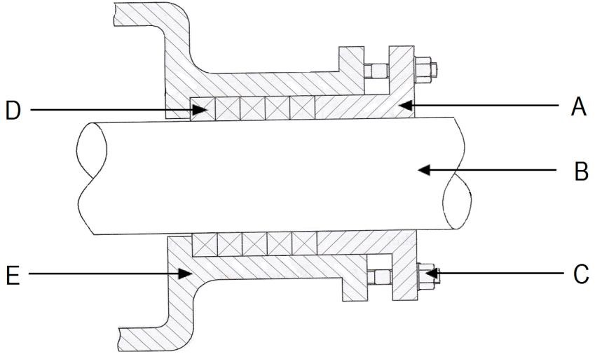

**FIGURE 2** (5)

6.2 Explain the difference between *thermoplastic piping* and *thermosetting plastic*

*piping.* (2)

6.3 State where each of the following fittings would be used in a water-pipe system:

6.3.1 90° elbow

6.3.2 Cross piece

(2 × 1) (2)

**[9]**

### QUESTION 7: PUMPS

7.1 State the THREE categories in which pumps are classified. (3)

7.2 FIGURE 3 shows a diagram of a vane pump.

Name the parts labelled A – C. Write only the answer next to the letter (A–C) in the ANSWER BOOK.

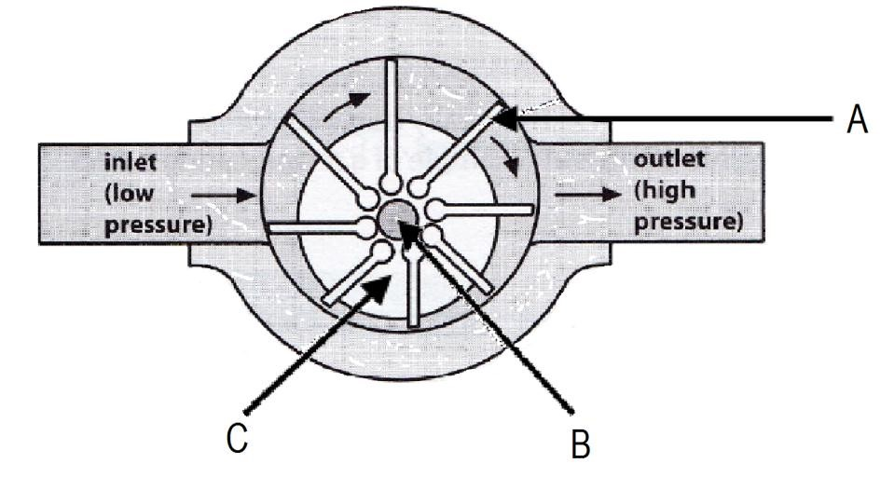

(3)

**FIGURE 3** **[6]**

### QUESTION 8: COMPRESSORS

Indicate whether the following statements are TRUE or FALSE. Choose the answer and write only 'true' or 'false' next to the question number (8.1–8.4) in the ANSWER BOOK.

8.1 Rotary air compressors are positive displacement air compressors.

8.2 In a multistage air compressor air is first admitted into the high-pressure cylinder and then transferred to the low-pressure cylinder.

8.3 Pressure gauges are fitted to compressors to indicate the temperature of the air.

8.4 Aftercoolers are used to cool the air after compression in the high-pressure cylinder has taken place.

(4 × 1) **[4]**

### QUESTION 9: V-BELTS, CHAIN DRIVES, GEAR DRIVES AND REDUCTION GEARBOXES

9.1 State TWO reasons for installing a guard around V-belts. (2)

9.2 Name the pulley fitted to the motor in a V-belt installation. (1)

9.3 State THREE advantages of gear drives compared to V-belt drives. (3)

9.4 List FOUR disadvantages of chain drives. (4)

9.5 Explain the term *reduction gearing*. (2)

**[12]**

**TOTAL SECTION A:**  **60**

**SECTION B**

Answer only TWO of the questions in Section B.

### QUESTION 10: HYDRAULICS AND PNEUMATICS

10.1 State the TWO most important factors in the functioning of a hydraulic

system. (2)

10.2 Hydraulic systems are made up of several components.

10.2.1 List any THREE components used to construct a hydraulic circuit. (3)

10.2.2 State ONE function of each of the components listed in Question

10.2.1 above. (3)

10.3 Hydraulic fluid serves several important functions in hydraulic systems. State

THREE functions of the hydraulic fluid. (3)

10.4 State FIVE advantages of pneumatic systems. (5)

10.5 Explain the functions of the following valves used in pneumatic systems:

10.5.1 Pressure relief valve

10.5.2 Regulator

10.5.3 Non-return valve

10.5.4 Directional control valve

(4 × 1) (4)

**[20]**

### QUESTION 11: CENTRE LATHES

11.1 What does CNC stand for? (1)

11.2 One of the methods used to cut tapers on the lathe is the compound slide method.

11.2.1 State THREE advantages of using this method. (3)

11.2.2 State THREE disadvantages of using this method. (3)

11.3 A three-start square thread with a pitch of 6 mm and an outside diameter of 42 mm must be cut on a centre lathe.

Calculate the following:

11.3.1 The lead of the thread (1)

11.3.2 The mean diameter of the thread (2)

11.3.3 The helix angle of the thread (2)

11.4 A workpiece with a diameter of 175 mm must be turned on a centre lathe.

Calculate the spindle speed in revolutions per minute if the cutting speed for

the material is 200 mm per second. (3)

11.5 Answer the questions about lathe steadies which are important accessories in the machining process.

11.5.1 State THREE uses of lathe steadies. (3)

11.5.2 Name the steady which is mounted to the lathe saddle. (1)

11.5.3 Name the steady which is mounted to the lathe bed. (1)

**[20]**

-9-

### QUESTION 12: MILLING MACHINES AND SURFACE GRINDERS

12.1 FIGURE 4 shows an accessory used on a milling machine.

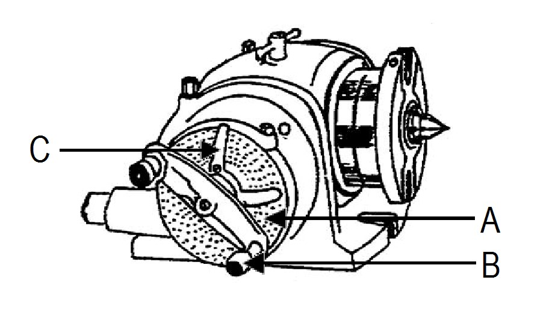

**FIGURE 4**

12.1.1 Name the accessory shown in FIGURE 4. (1)

12.1.2 State the function of this accessory. (1)

12.1.3 Name the labelled parts by writing the answer next to the letter (3) (A–C) in the ANSWER BOOK.

12.2 A milling machine is used to cut 9 evenly spaced grooves around a shaft.

Calculate the required indexing using the Brown and Sharp dividing head.

|  |  |  |  |  |  |  |
| --- | --- | --- | --- | --- | --- | --- |
|  | **THE BROWN AND SHARP DIVIDING HEAD** | | | | |  |
|  | Number of holes | | | | |  |
| Plate 1 | 15 | 16 | 17 | 18 | 19 | 20 |
| Plate 2 | 21 | 23 | 27 | 29 | 31 | 33 |
| Plate 3 | 37 | 39 | 41 | 43 | 47 | 49 |

(5)

12.3 List FIVE reasons for the use of small diameter cutters. (5)

12.4 Name the abrasive material used to grind each of the following:

12.4.1 Carbon steel

12.4.2 Soft bronze

(2 × 1) (2)

12.5 Name THREE faults associated with surface grinding. (3)

**[20]**

**TOTAL SECTION B:**   **40**

**GRAND TOTAL:**  **100**

T700(**E**)(A4)T

**FITTING AND MACHINING THEORY N2**

### FORMULA SHEET

ƒ =ƒ × T × N

